Access network – physical network to connect end-system to the first router or the edge router.

Types of access network:

* Home
* Enterprise
* Wide-area
* Mobile

Интернет в домике:

* Телефонная линия
* Телевизионный кабель (коаксиальный)

The two most popular types of broadband access are:

* DSL (digital subscriber line) and cable
* CIA (Cable Internet Access)

DSL Internet access is obtained from local telephone company. The telephone line carries both data and traditional telephone signals simultaneously.

Each customer`s DSL modem uses an existent telephone line to exchange data with DSLAM (Digital Subscriber Line Access Multiplexor) located in the telephone company.

Home DSL modem takes digital data and translates to high-frequency tones.

While DSL uses telephone line, cable internet access uses of the cable television existent cable.

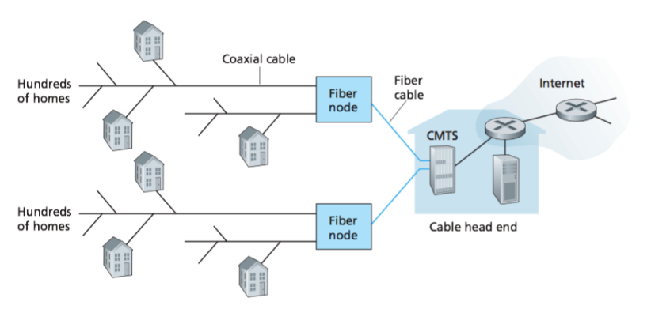

Cable Internet Access requires special modem, that connected to home PC throught Ethernet port.

One important characteristic of CIA is that it’s shared broadcast medium.

On corporate network or uni is used LAN to connect to the edge router.

Ethernet uses a twisted pair coper wire to connect to the Ethernet switch.

There are two types of wireless access networks:

* wireless LAN (home)
* Wide-area wireless access (uses the same wireless infrastructure used for cellular telephone)

Physical media:

* Twisted pair
* Coaxial cable
* Multi-mode fiber optic cable
* Radio spectrum
* Satellite radio spectrum

Physical media types:

* Guided media (cables)
* Unguided media (radio)

Twisted pair consists of two isolated coper wires. The wires twisted together to reduce the electrical interference. Wired pair constitutes a single communication …

Coaxial cable consists of two coper conductors, but they are concentric.

An optic fiber is a thick flexible medium, that conducts pulses of light, where each pulse represents a bit.

Radio channels carry signals in a electro-magnetic spectrum.

There are two types of satellites:

* Geostationary
* Low-earth orbiting